**1949 Dodge Power Wagon For Sale**

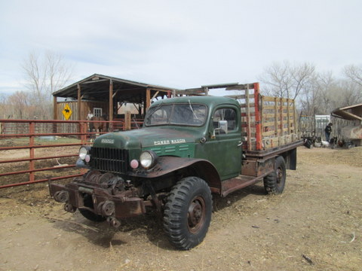

**If you are looking for a Power Wagon to restore, this truck is an excellent candidate!!**

**Year: 1949 Body Style: Flat Bed, Mileage: 66,000, Engine: Stock Flat Head 231 CI, Serial Number: 839228706, Model: B-3-PW-I26 Winch: Braden MU2 PTO Powered.**

**Price: $8,500,00 cash OBO. The asking price is based on the overall excellent condition of this truck. I am selling this truck because I already have a Power Wagon and do not need two.**

**Truck’s Status: This Power Wagon is 100% complete other than a couple of missing door handles. It has four (4) NEW non-directional tires and a spare wheel and tire that holds air. The body has *NO RUST* and is very clean, straight and in excellent condition. It also has the original paint. The flat bed (serial # 6368) was manufactured and installed by Timpte Brothers of Denver Colorado. The flatbed frame rail is in excellent condition and all the stake holes are clean and straight. The wood deck has rotted out and would need to be replaced. The flat bed comes with a set of oak stock racks which are pretty well weathered but would be good for the patterns for a new set of racks. The engine is complete but appears to be locked up, reason unknown. As with a truck that is 69 years old the wiring would have to be redone. The truck does not have a current title. The pack rats got to the seat so all that is left is a good set of seat springs. Truck has been parked for 20 +/- years.**

**Modifications: As with some of these trucks this one has not been heavily modified. There are some “A” Frame brackets that have been welded to the front bumper. These brackets could be easily removed. There is a set of double overload springs on the rear axle. The frame has been “fish plated” but it does not appear that this was done because the frame was broken, so it was done to prevent the frame from being damaged.**

**Truck’s History: I am only the second owner of this truck. I purchased the truck from Rex Kleitz, a retired rancher in southern New Mexico. Rex and his father had a ranch in northwestern Colorado. They purchased the truck as a cab and chassis unit in 1949. The truck was sent to Timpte Brothers Manufacturing in Denver to have a flat stake bed and stock racks installed. The Kleitzs moved the ranching operation to southern New Mexico in the early 1960’s and brought the Power Wagon with them. Rex told me the truck made a couple of moving trips from Colorado to New Mexico. On one trip they moved two of their prize Herford bulls. The bulls were fed and watered in the back of the truck until they were unloaded at the New Mexico ranch. Rex said it took about twenty hours to make the trip driving straight through. The truck saw general ranch use. The winch was set up with an “A” frame boom that was used to pull the pump systems on windmills so they could be repaired and reinstalled. The truck appears to have been well maintained and taken care of: one clue to this is that the body is in such excellent condition, which is very rare for this is type and year of truck.**

**Contact: Steve Carson 505-470-3542 rangehands@gmail.com**